

**Pokhara University Affiliate**

**LA GRANDEE INTERNATIONAL COLLEGE**

**Simalchaur, Pokhara Nepal**

Project Defense On

**“Bakery System Management”**

**Submitted to:**

Bachelor of Computer Application(BCA) Program

In partial fulfilment of the requirements for the degree of BCA under

Pokhara University

**Submitted by:**

|  |  |  |  |
| --- | --- | --- | --- |
| **Name:** | **Course** | **Semester** | **P.U. Registration Number** |
| Aakriti Parajuli | BCA | 6th | 2021-1-53-0345 |
| Sambhawi Baral | BCA | 6th | 2021-1-53-0365 |
| Rebecca Ghimire | BCA | 6th | 2021-1-53-0361 |
|  | **Date:10/2/24** |  |  |

**Table of Contents**

1. Introduction 1

2. Problem Statement 2

3. Objectives 3

4. Methodology 4

5. Project Gantt Chart 6

6. Deliverables 7

7. References 8

**List Of Figures**

Figure 4. 2 Spiral Model 7

Figure 5. 1 Gantt Chart 8

# **Introduction**

A Bakery System Management ecommerce platform is a valuable tool for bakery businesses looking to improve efficiency, enhance customer satisfaction and drive growth. Bakery System Management is the way of reducing the workload environment and enhancing the working system. By addressing the challenges faced by traditional bakery operations, these platforms can help bakeries stay competitive in today’s fast placed market.

The bakery management system is designed to streamline and automate the daily operations of a small bakery. The system is especially suited for small bakeries with a limited number of employees, helping to ensure that all operations run smoothly and efficiently.

The system allows the customer to shop online and browse the available products. Through this system, bakery owners can track customer orders and manage inventory levels effectively, and ensure better customer experience. The user-friendly interface allows bakery owners to manage their business operation from any location, providing greater flexibility and control.

The primary goal of this project is to provide a comprehensive bakery management system through this platform, built with php, html and css. Built using php, this system provides bakery owners with an efficient way to manage key aspects of their business, including customers, orders, products and inventory. This solution not only simplifies the operational management of a bakery but also enhances the overall customer experience by offering secure, efficient order fulfillment.

The system allows the admin to manage products, orders and view reports efficiently, whereas the customers can view the product create the wish-list and can purchase the item. The system will not only modernize the bakery’s operations but also help the business scale by reaching a wider audience through the internet.

# **Problem Statement**

A local bakery wants to digitize its operations by creating an e-commerce platform that allows customers to browse and orders, which limits its growth and reach. With increasing demand and competition, the bakery needs an efficient system that allows customers to order products at their convince. As well local bakeries struggle to reach a large audience and handle online audience and handle online orders efficiently. Customers prefer the convenience of ordering products online, but many bakeries don’t have the technology to offer this service. There has been a significant change and shift towards online shopping, including food-related purchases. Small bakeries need to adapt to this trend to stay competitive. Various existing platforms provide e-commerce services, but this project aims to cater specifically to bakery needs.

* Customers Service Challenges: Difficulty in managing customer orders, providing timely customer support and maintaining customer satisfaction.
* Limited Data Insite: Lack of access to real time data and analytics to make informed business decision.
* Manual operations are inefficient: small bakeries struggle with time consuming manual processes for managing orders, inventory and customer data.
* Limited staff resources: bakeries with a few employees face difficulties handling multiple business aspects simultaneously.

# **Objectives**

The objective of this project is to develop a bakery e-commerce platform using php, css, html that will allow customers to easily browse, order, and see the availability for bakery products online. To improve business flexibility with a user friendly interface that allows bakery owners to manage operation remotely. Enchance customer experience. The main objective of this project:

* Built a user-friendly bakery e-commerce website.
* Allow customers to view and purchase bakery items online.

# **Methodology**

Spiral model is a risk driven software development process model. It provides a framework for designing processes including the risk levels associated with them. A spiral model is a cyclic model. It allows the rapid generation of subsequent phases during the software development phases. It also allows checking the robustness and correctness of the phases. After each cycle a prototype is developed and checked for its robustness and to meet the requirements.

Phases of the spiral model:

* Objectives Defined: In first phase of the spiral model clarify what the project aims to achieve, including functional and non-functional requirements.
* Planning Phase: All the required information about the project will be gathered in this phase. Requirements such as system requirement specifications, design alteration, etc. will be done in this phase
* Risk Analysis: Requirements of the project is studied and brainstorm sessions are conducted to figure out potential risks involved. In the risk analysis phase, the risks associated with the project are identified and evaluated at the beginning of each iteration, and appropriate actions are taken to mitigate them.
* Engineering: In the engineering phase, the software is developed based on the requirements gathered in the previous iteration.
* Testing Phase: Testing alongside developmental changes will be done in this phase. Coding, test case development, test execution, test summary report, defect report generation, etc. happens in this phase.
* Evaluation: In the evaluation phase, the software is evaluated to determine if it meets the customer’s requirements and if it is of high quality. Feedback is gathered and used to refine the requirements for the next iteration.

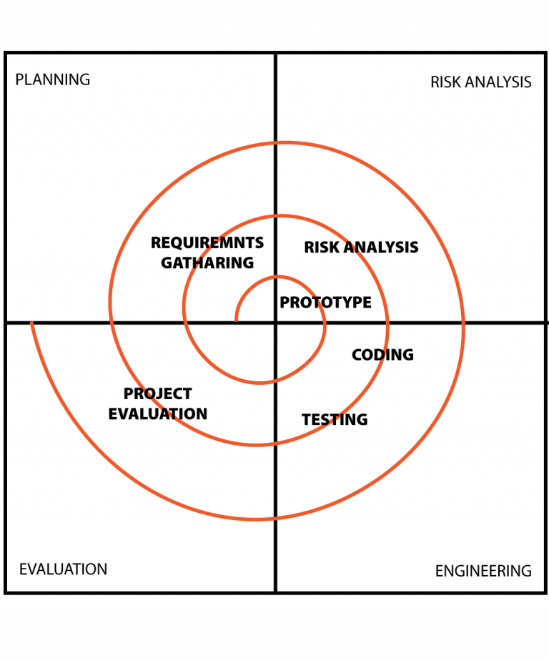(testbytes, 2019)

Figure 4. 2 Spiral Model

Each spiral that can be seen in the diagram above acts as a loop for a separate process in testing. The four main activities, planning risk analysis, testing, coding and project evaluation will be repeated again for the required amount of phases for any project.

# **Project Gantt Chart**

The Gantt chart below shows the schedule planned for developing the “Bakery Management system”. This project would be carried out in steps with proper planning in each step, best effort would be applied to finish this project before deadline.

Figure 5. 1 Gantt Chart

# **Deliverables**

The system wants to:

* Offers a wide range of products (cakes, bread, cookies, pastries, etc.) online.
* Provide a seamless and intuitive shopping experience.
* Ensure secure user authentication.
* Simplify the ordering process for customers.
* Customer can view, browse, add product for purchase.

The system will help the bakery owner/admin manage the business more effectively by providing tools to:

* Add and update product listings.
* View and manage products and customer orders.
* Track sales data and generate reports.
* Managing inventory and updating product availability.
* Integrating a user-friendly interface for customers to place orders.

.

# **References**

Kumar, A. (2015). *online cake bakery management system in PHP*. Retrieved from PHPGurukul.com: https://phpgurukul.com/

testbytes.(2019).Retrievedfromtestbytes: https://images.app.goo.gl/T7B1Bmu13N2iwGjc7